|  |
| --- |
| MYSQL JOINS |
| REFERENCE BOOK |
| ADARSH KUMAR & RADHA SINGH |

|  |  |  |  |
| --- | --- | --- | --- |
| ADARSH.JPG |  | DSCN0529.JPG |  |
| Adarsh kumar | Radha Singh |
| Java.adarsh1983@gmail.com | oracle.radhasingh@gmail.com |
| Scjp,Scwcd,Ocwsd,Ocp | Oca ,Ocp |
| Oca |  |

|  |  |  |  |  |  |  |
| --- | --- | --- | --- | --- | --- | --- |
| java_cert_prog.bmp | java_cert_web_comp_dev.bmp | OCP_JavaEE5WebServicesDev_clr.bmp | OCP_JavaSE5Programmer_clr.bmp | OCE_ODbSQL_clr.bmp | OCA_PLSQLDev_clr.bmp | OCP_AdvPLSQLDev_clr.gif |

**MYSQL JOINS EXAMPLES**

***Table One data***

DROP TABLE IF EXISTS `practice`.`tableone`;

CREATE TABLE `practice`.`tableone` (

`id` int(10) unsigned NOT NULL AUTO\_INCREMENT,

`name` varchar(45) NOT NULL,

PRIMARY KEY (`id`)

) ENGINE=InnoDB AUTO\_INCREMENT=11 DEFAULT CHARSET=latin1;

LOCK TABLES `tableone` WRITE;

INSERT INTO `tableone`

VALUES (1,'Adarsh')

,(2,'Amit')

,(3,'Radha')

,(4,'Sonu')

,(5,'Monu')

,(6,'TableOne6')

,(7,'TableOne7')

,(8,'TableOne8')

,(9,'TableOne9')

,(10,'TableOne10');

UNLOCK TABLES;

SELECT \* FROM tableone t;

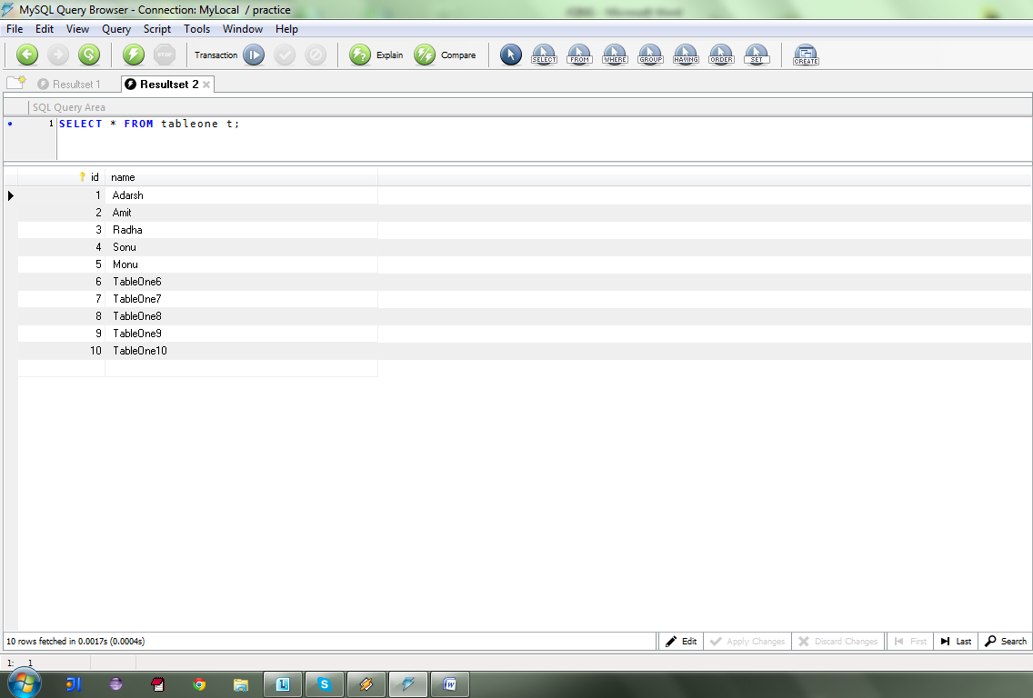

***Table Two data***

DROP TABLE IF EXISTS `practice`.`tabletwo`;

CREATE TABLE `practice`.`tabletwo` (

`id` int(10) unsigned NOT NULL AUTO\_INCREMENT,

`name` varchar(45) NOT NULL,

PRIMARY KEY (`id`)

) ENGINE=InnoDB AUTO\_INCREMENT=11 DEFAULT CHARSET=latin1;

LOCK TABLES `tabletwo` WRITE;

INSERT INTO `tabletwo`

VALUES (1,'Adarsh')

,(2,'Amit')

,(3,'Radha')

,(4,'Sonu')

,(5,'Monu')

,(6,'TableTwo6')

,(7,'TableTwo7')

,(8,'TableTwo8')

,(9,'TableTwo8')

,(10,'TableTwo10');

UNLOCK TABLES;

SELECT \* FROM tabletwo t;

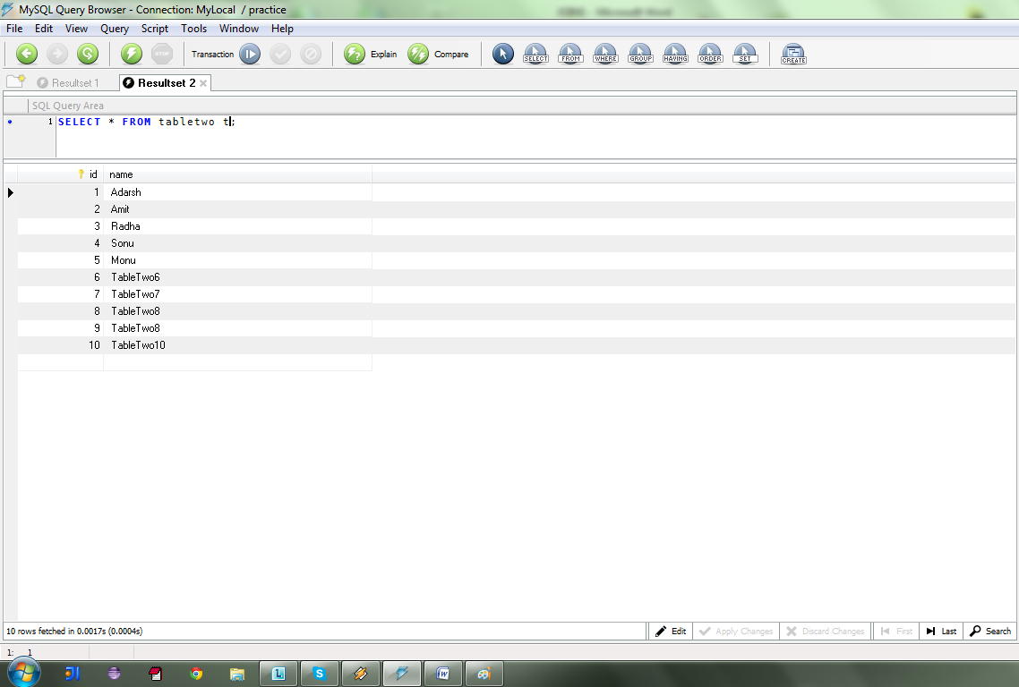

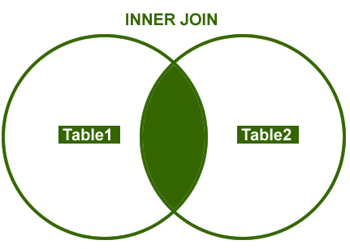

SELECT

t1.id tableOne\_id

,t1.name tableOne\_name

,t2.id tableTwo\_id

,t2.name tableTwo\_name

FROM

TableOne t1 INNER JOIN TableTwo t2

ON t1.name = t2.name;

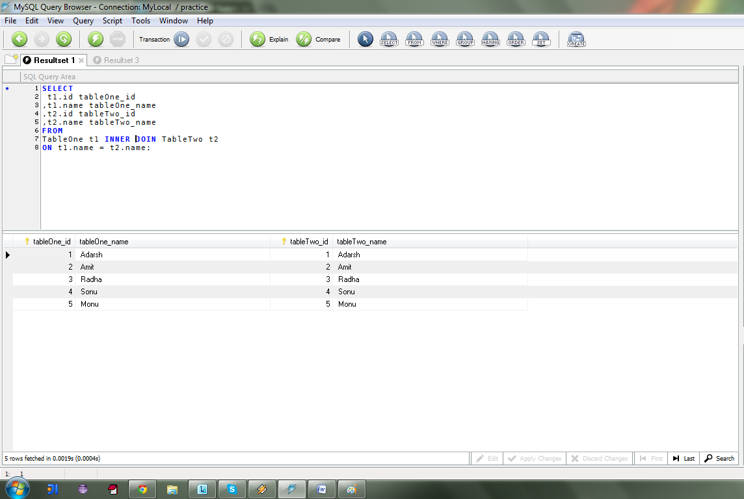

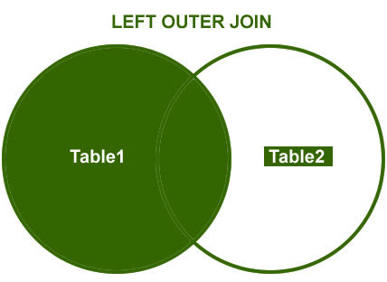

SELECT

t1.id tableOne\_id

,t1.name tableOne\_name

,t2.id tableTwo\_id

,t2.name tableTwo\_name

FROM

TableOne t1 LEFT OUTER JOIN TableTwo t2

ON t1.name = t2.name;

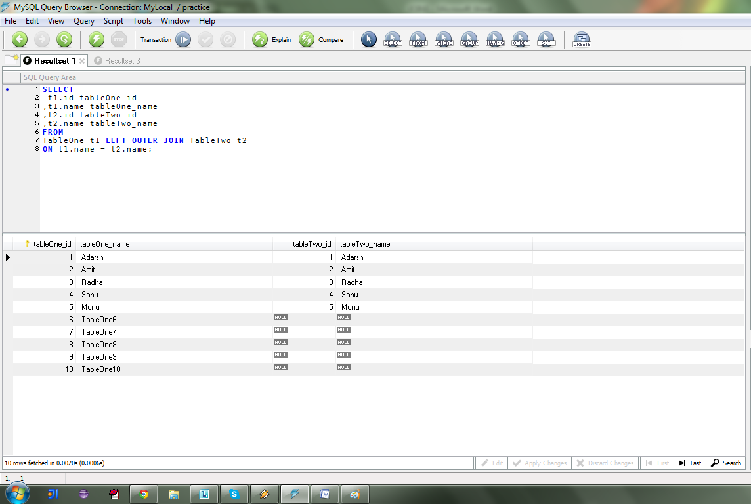

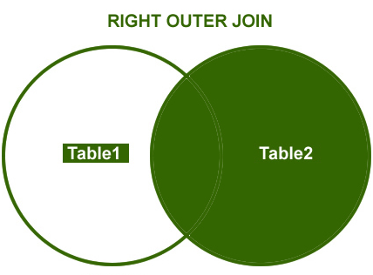

SELECT

t1.id tableOne\_id

,t1.name tableOne\_name

,t2.id tableTwo\_id

,t2.name tableTwo\_name

FROM

TableOne t1 RIGHT OUTER JOIN TableTwo t2

ON t1.name = t2.name;

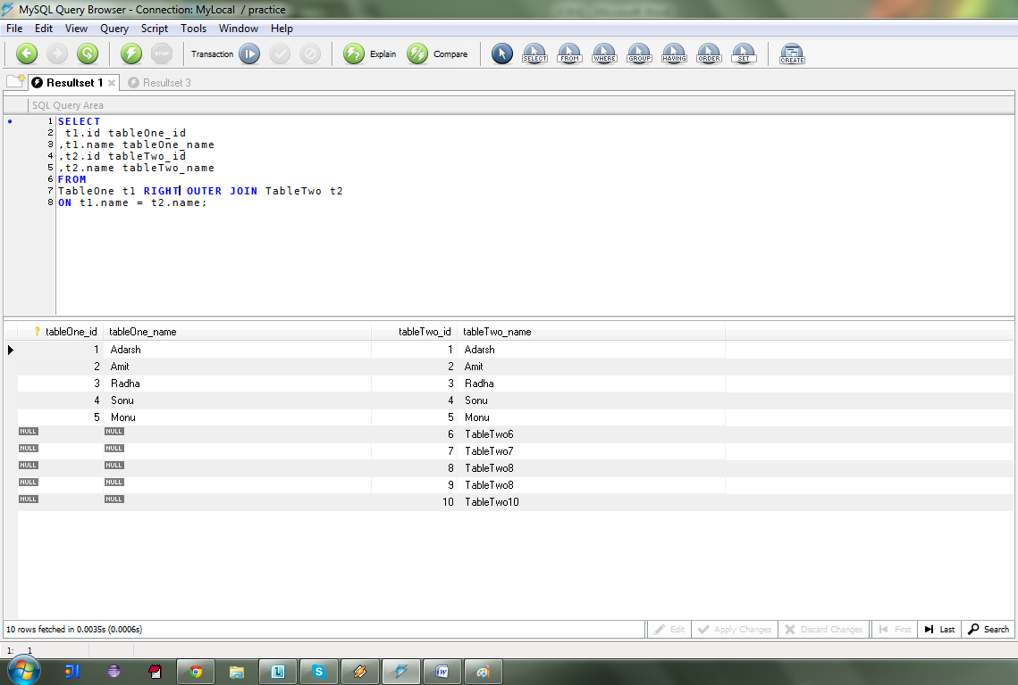

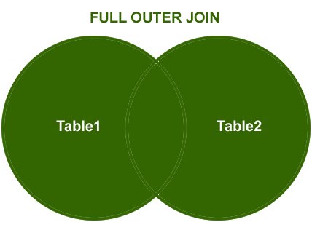

SELECT t1.id tableOne\_id ,t1.name tableOne\_name ,t2.id tableTwo\_id ,t2.name tableTwo\_name

FROM TableOne t1 LEFT OUTER JOIN TableTwo t2

ON t1.name = t2.name

UNION

SELECT t1.id tableOne\_id ,t1.name tableOne\_name ,t2.id tableTwo\_id ,t2.name tableTwo\_name

FROM TableOne t1 RIGHT OUTER JOIN TableTwo t2

ON t1.name = t2.name;

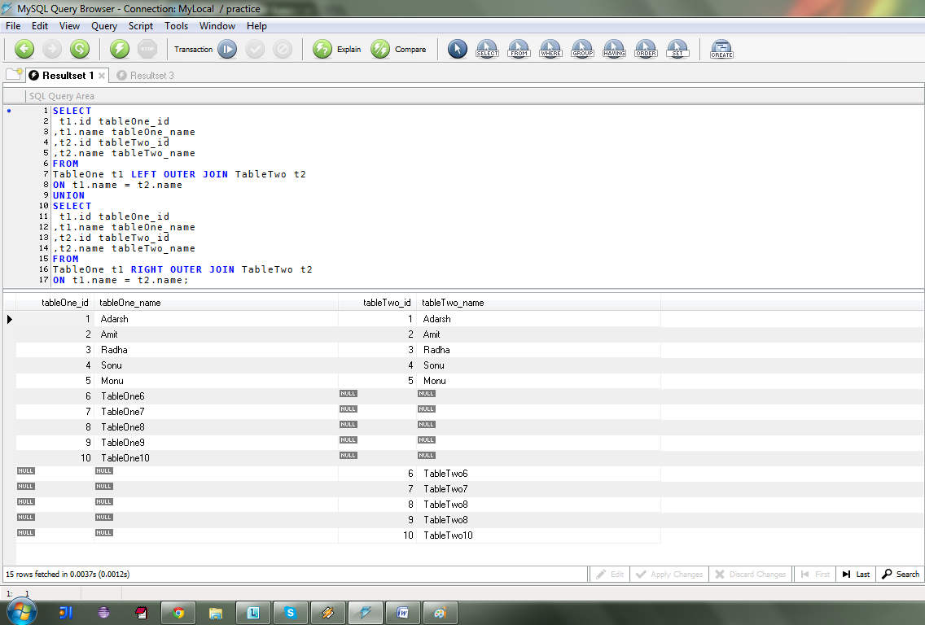

**CROSS JOIN**

SELECT

t1.id tableOne\_id

,t1.name tableOne\_name

,t2.id tableTwo\_id

,t2.name tableTwo\_name

FROM

TableOne t1 JOIN TableTwo t2;

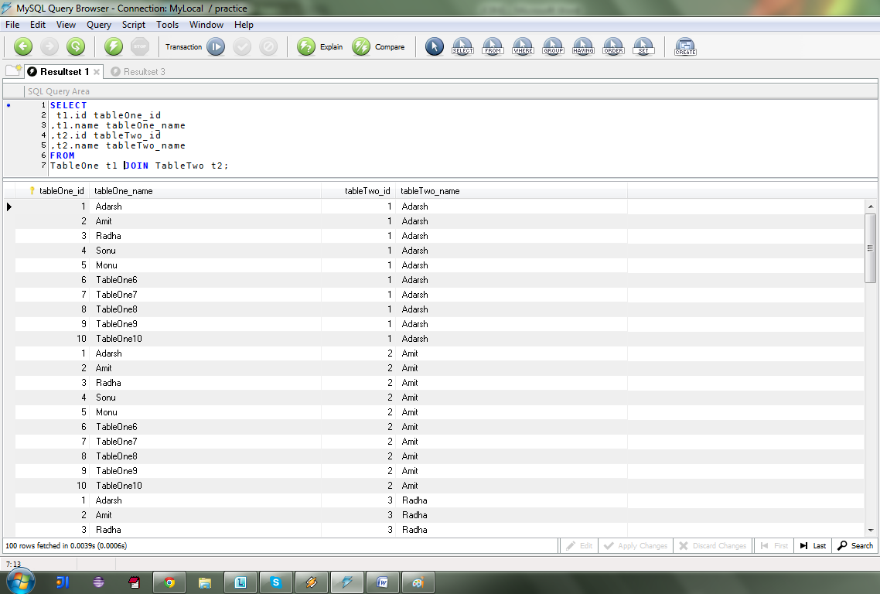

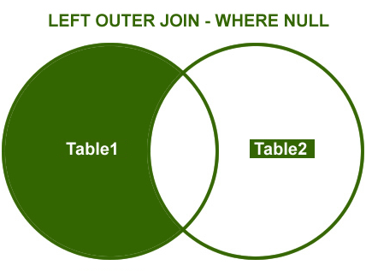

SELECT

t1.id tableOne\_id

,t1.name tableOne\_name

,t2.id tableTwo\_id

,t2.name tableTwo\_name

FROM

TableOne t1 LEFT OUTER JOIN TableTwo t2

ON t1.name = t2.name

WHERE t2.name IS NULL;

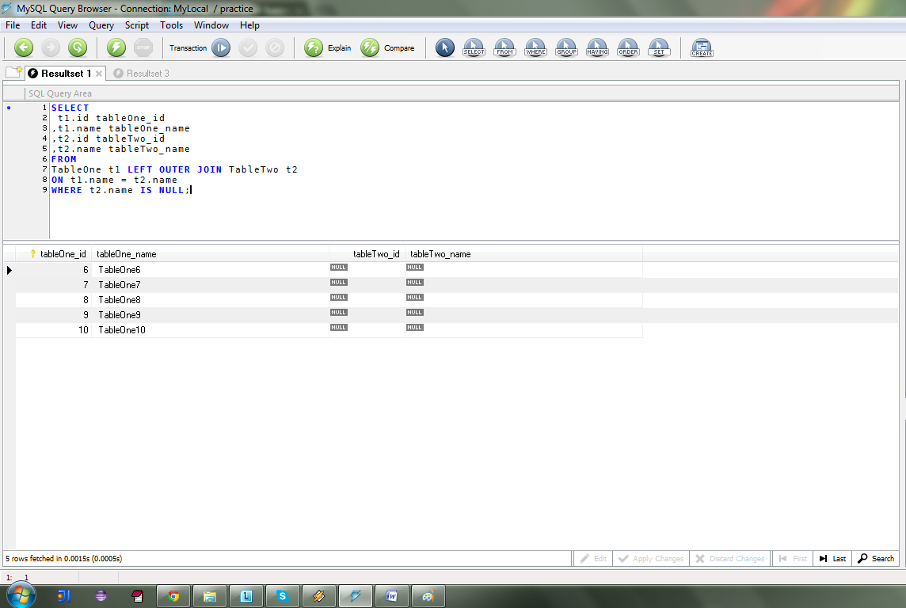

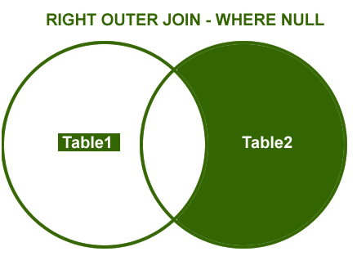

SELECT

t1.id tableOne\_id

,t1.name tableOne\_name

,t2.id tableTwo\_id

,t2.name tableTwo\_name

FROM

TableOne t1 RIGHT OUTER JOIN TableTwo t2

ON t1.name = t2.name

WHERE t1.name IS NULL;

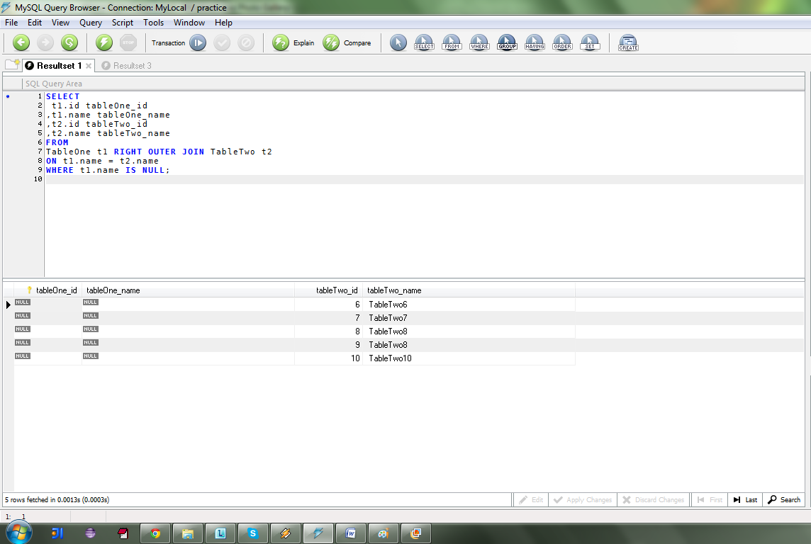

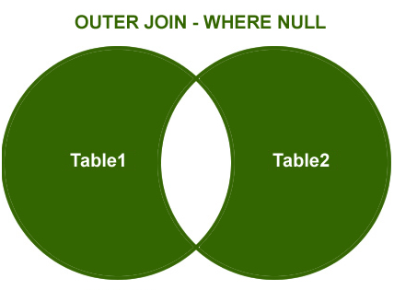

SELECT

t1.id tableOne\_id ,t1.name tableOne\_name ,t2.id tableTwo\_id ,t2.name tableTwo\_name

FROM TableOne t1 LEFT OUTER JOIN TableTwo t2

ON t1.name = t2.name

WHERE t2.id IS NULL

UNION

SELECT t1.id tableOne\_id ,t1.name tableOne\_name ,t2.id tableTwo\_id ,t2.name tableTwo\_name

FROM TableOne t1 RIGHT OUTER JOIN TableTwo t2

ON t1.name = t2.name

WHERE t1.id IS NULL;

